THE MALAYSIAN JOURNAL OF MEDICAL SCIENCES
AUTHORSHIP AGREEMENT FORM

Date: 9 September 2026
Manuscript title: Short-Term Effectiveness of Bodyweight Soleus Push-Up in Reducing Blood Glucose Levels among Patients with Type 2 Diabetes Mellitus: A Quasi-Experimental Study

The completed forms must be mailed to the Editor, Malaysian Journal of Medical Sciences, USM Press, c/o School of Medical Sciences, Universiti Sains Malaysia Health Campus, Kubang Kerian, 16150 Kota Bharu, Malaysia or faxed to +609 767 2359

ETHICAL REQUIREMENT
The authors attest that full and informed consent was obtained from human subjects and that the work was performed in accordance with the humane and ethical principles of research outlined in the Helsinki guidelines. In countries where institutional review is established, this statement also attests to the approval of that institution of the protocol for all aspects of the investigation presented in a manuscript involving humans or animals.

CONFLICT OF INTEREST AND FINANCIAL SUPPORT
The undersigned authors agree that any financial interests that exist for individual contributors in connection with this manuscript have been disclosed in the covering letter submitted through Manuscript Central. Sources of financial support of the project are named in the covering letter as well as in the Acknowledgements.

DUPLICATE PUBLICATIONS
The undersigned Author(s) certify that neither this manuscript nor one with substantially similar content under their authorship has been published or being considered for publication elsewhere in any language. They also certify that any previous presentations of this paper in meetings are mentioned in the covering letter.

AUTHORSHIP
Author(s) attest that all persons designated as authors qualify for authorship and all those who qualify are listed. All others who contributed to the work but are not authors (if any) are named in the Acknowledgements of the manuscript.

In the space marked “Contribution Codes”, authors should mark those code letters from the box that designate their own substantive contribution(s) to the paper.

Names of all authors
Contribution  codes* | Author’s Name | Signature
A, C, D, E | Cholik Harun Rosjidi | 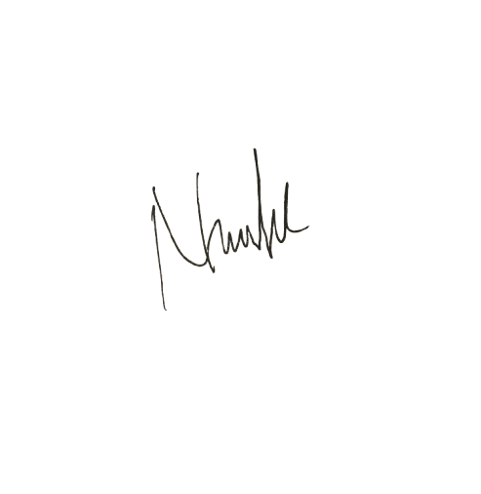
A, D, E, F | Narmawan
C, E, F | Risnawati | 
D, E, F | Siti Umrana | 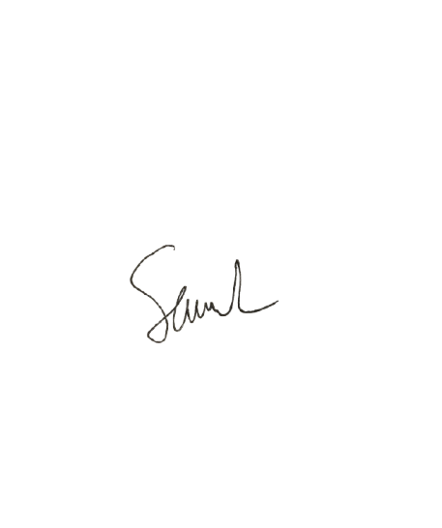
B, E, G | Muhammad Syahwal | 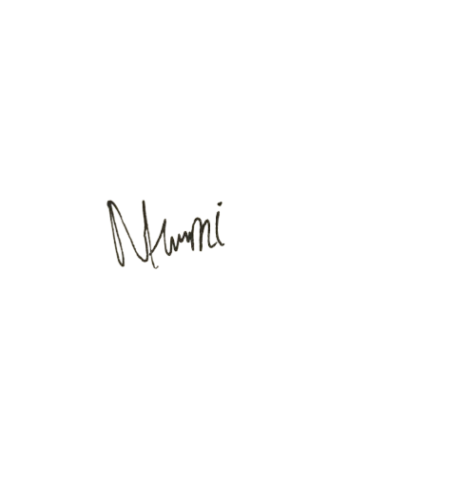
C, E, F | Narmi | 
D, E | Mien | 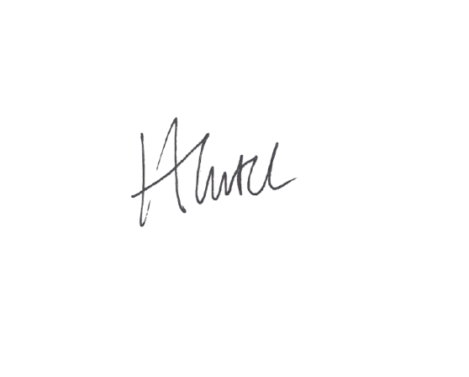
E, F | Hasrima | 
B, D, E, G | Herman | 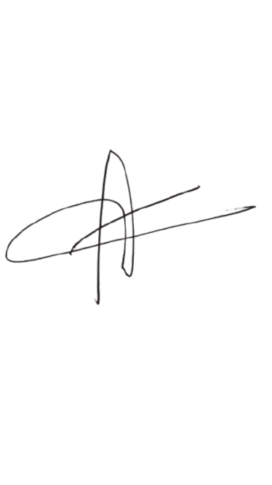  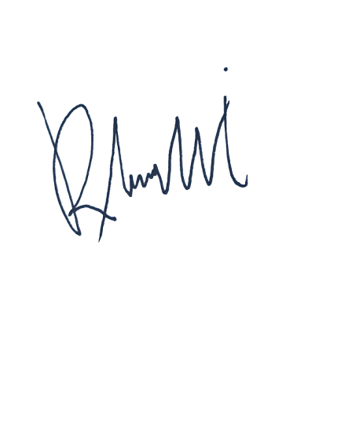
A, D, E | Mubarak
C, E, F | Rahmawati A
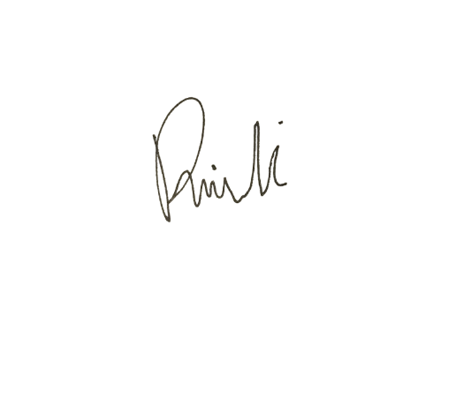

Contribution codes

A : Conception and design
B : Analysis and interpretation of the data
C : Drafting of the article
D : Critical revision of the article for important intellectual content
E : Final approval of the article
F : Provision of study materials or patients
G : Statistical expertise
H : Obtaining of funding
I : Administrative, technical, or logistic support
J : Collection and assembly of data

